ISLAMIC UNIVERSITY OF TECHNOLOGY

Organization of Islamic Cooperation

Board Bazar, Gazipur

Laboratory Report

CSE 4512

**Title**: Familiarizing with the Packet Tracer Environment

**Objectives**:

* Download and install Cisco Packet Tracer
* Learn about use-cases of Cisco Packet Tracer
* Get acquainted with different components of Cisco Packet Tracer environment
* Understand how to operate Cisco Packet Tracer

**Introduction**:

Cisco Packet Tracer is a simulation program that allows us to create networks that use a large number of devices without having any of those devices physically available. This removes a lot of the financial and physical limitations faced in educational environments and allows demonstrations of actual network behavior.

Cisco Packet Tracer is used for:

* Network Design – Network administrators can use the software to try out different scenarios before applying them in the real world.
* Education – Instructors can use the program to give demonstrations of how actual networks work without using any physical network devices.
* Certification – The program is essential for preparation for network examinations, like the Cisco Certified Network Associate (CCNA) examinations.

**Interface of Cisco Packet Tracer**:

Menu Bar:



The Menu Bar consists of a total of eight tabs.

The File tab contains actions related to the files being worked on such as creating new files, opening old files and saving or printing opened files. Additionally, the File tab contains the option to close the program.

The Edit tab contains four basic actions: Copy, Paste, Undo and Redo.

The Options tab provides actions that allow us to view and change settings and information related to how the program works.

The View tab has actions that allow us to change visible parts of the program.

The Tools and Extensions tabs provide additional utilities.

The Window tab allows us to toggle between Windowed mode and Full Screen. It also lists any windows we open through the program.

The Help tab contains links to tutorials, documentation and error reporting.

Main Tool Bar:



The Main Tool Bar contains the most commonly used actions from the Menu Bar for quick and easy access.

**Logical/Physical Workspace and Navigation Bar**:





On the left-hand side of this bar, there is the option to toggle between the Logical and the Physical workspace. In the Logical workspace, we can create logical network topologies. We can experiment with the placement and connections of different network devices here. The Physical workspace shows us what the logical network we created would look like in the real world. It allows us to gain a sense of the scale and placement of the different devices and connections in a real environment, using graphical representations of networks, cities, buildings and wiring closets.

On the right-hand side are a range of options that allow us to change visible elements in the workspace. The exact options available vary depending on whether we are in the Logical or the Physical workspace. In the Logical workspace, we have options to create a new cluster. In the Physical workspace, we have options to create new cities, buildings, generic containers, closets, racks, tables and inventory shelves. In both workspaces, we have the option to move around an object, set the background image and change a large variety of settings related to the physical environment such as atmospheric pressure, wind speed, elevation, etc.

**Realtime/Simulation Bar**:





The Realtime/Simulation Bar allows us to toggle between the Realtime and Simulation Packet Tracer modes. In Realtime mode, the network behaves like a real network, giving real-time responses to all activities. This allows us to experience a real network without using any actual hardware. In Simulation mode, we can control time intervals and how data travels along the network. This allows us to gain a better understanding of what is going on inside the network.

On the left-hand side of the bar, we have a few more options. In Realtime mode, we can power cycle devices and fast forward through time. In Simulation mode, we have the additional options to play events and toggle the event list.

**Network Component Box**:

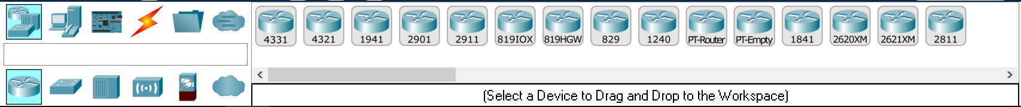

The Network Component Box contains different devices and connections which we can use in the workspace. It has two parts, the Device-Type Selection Box and the Device-Specific Selection Box.

**Device-Type Selection Box**:

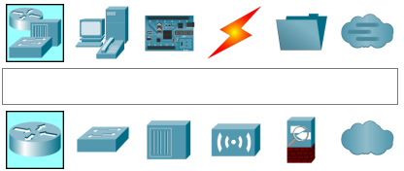

The Device-Type Selection Box contains different categories of devices that are available for use. For example, in the ‘End Devices’ category, there are sub-categories for ‘Home’, ‘Smart City’, ‘Industrial’ and ‘Power Grid’. Depending on which category and sub-category we select, a different set of devices will be shown in the Device-Specific Selection Box.

This box also contains a search bar where we can search for specific devices by name. The search results will show up in the Device-Specific Selection Box. When hovering our mouse over a category or a sub-category, the name of the category or sub-category shows up in the search box.

**Device-Specific Selection Box**:

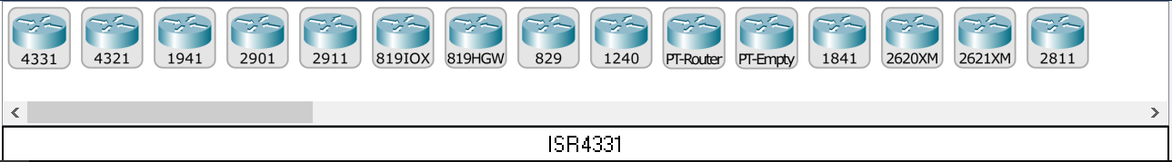

The Device-Specific Selection Box allows us to select specific devices. Depending on which category and sub-category we picked in the Device-Type Selection Box, a different set of devices will be shown. We can then drag in the device that we want into the workspace. When hovering our mouse over a specific device, the name of the device shows up in the bar at the bottom.

**User Created Packet Window**:

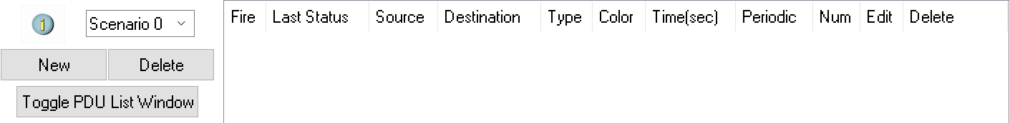

In Simulation mode, we can create packets to send between devices and view how those packets travel through the network. The packets we create and some details about each packet are visible in the User Created Packet Window.

**Key Features of Cisco Packet Tracer**:

A few of the key features of Cisco Packet Tracer are:

* Can include an unlimited number of devices in simulations
* Can be used for e-learning
* Provides an interactive environment
* Allows visualization of networks
* Provides both real-time and simulation packet tracer modes
* Supports the majority of networking protocols
* Supports a multitude of languages
* Provides cross platform compatibility

**Challenges faced and Solutions**:

The first major challenge was related to the display scaling of the software. I faced an issue with the content of the display being scaled up to a very large extent. Essentially, everything was huge. This made it difficult and irritating to navigate the program. The general solutions for a situation like this (decreasing display scaling from Windows settings and changing the high DPI settings for the executable file) failed to fix the problem. After an extensive amount of research I discovered that Cisco Packet Tracer is built on Qt, which seems to have some issues with high DPI scaling. I had to edit some environment variables to fix the issue. This information was only found when researching a similar issue I faced with the Qt Creator software.

Another major challenge was understanding what was required in this assignment. This assignment was different from anything I have done before, and I struggled to understand what information I should include and the extent to which I should describe things. I started off trying to write at least something about every single button before backtracking and deciding to give a more general description of the features available, since I realized it would not be possible to describe everything. To be honest, I am still not confident about this.

**References**:

1. [Cisco Packet Tracer Data Sheet](https://www.cisco.com/c/dam/en_us/training-events/netacad/course_catalog/docs/Cisco_PacketTracer_DS.pdf)
2. Cisco Packet Tracer Help Section
3. [GeeksforGeeks – What is Cisco Packet Tracer](https://www.geeksforgeeks.org/what-is-cisco-packet-tracer/)